1. Method

We will use a neural network to approximate both the **Runge function** and its **derivative**.

$f\left(x\right)=\frac{1}{1+{25x}^{2}}$ $f^{'}\left(x\right)=-\frac{50x}{{\left(1+25x^{2}\right)}^{2}}$ $x←\left[-1,1\right]$

Loss Function:

$$L\left(θ\right)=\left(\frac{1}{N}\right)*\sum_{i}^{N}{{\left(y_{i}-{\check{y}}_{i}\right)}^{2}+{\left({y^{'}}_{i}-{\check{y}'}_{i}\right)}^{2}}$$

And its gradient:

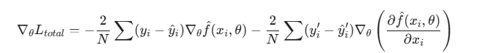

1. result

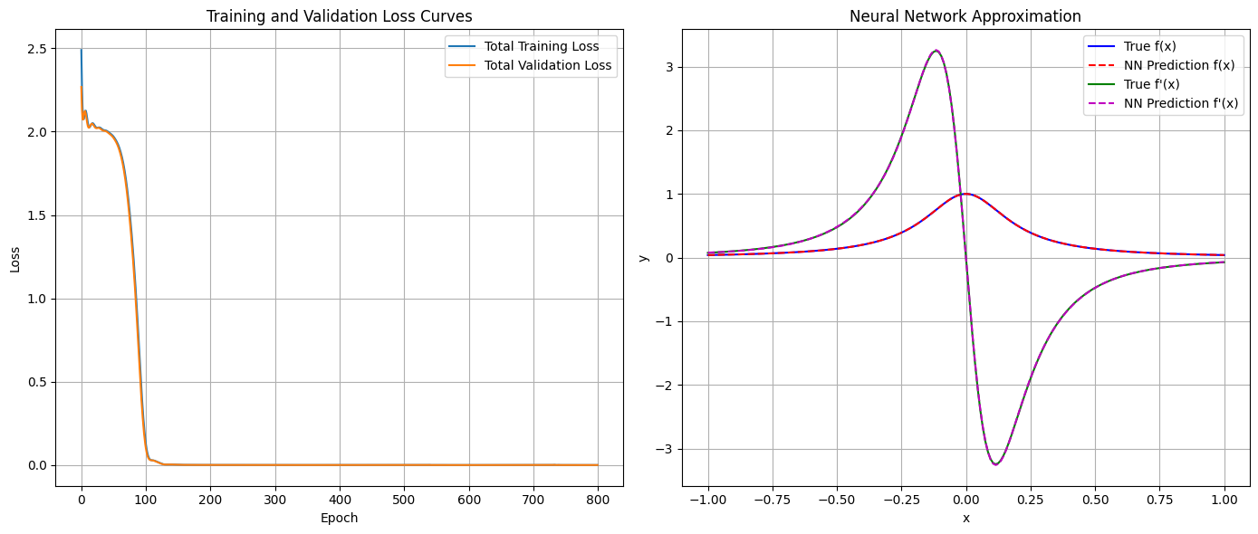

Epoch 100/800 -> Train Loss: 0.15499093, Val Loss: 0.12372499

Epoch 200/800 -> Train Loss: 0.00056474, Val Loss: 0.00055885

Epoch 300/800 -> Train Loss: 0.00031473, Val Loss: 0.00031329

Epoch 400/800 -> Train Loss: 0.00020587, Val Loss: 0.00020491

Epoch 500/800 -> Train Loss: 0.00012884, Val Loss: 0.00012814

Epoch 600/800 -> Train Loss: 0.00008002, Val Loss: 0.00007869

Epoch 700/800 -> Train Loss: 0.00004824, Val Loss: 0.00004796

Epoch 800/800 -> Train Loss: 0.00003201, Val Loss: 0.00003128

--- 最終誤差評估 ---

訓練集 - 函數 MSE: 0.00000028

訓練集 - 導數 MSE: 0.00003172

驗證集 - 函數 MSE: 0.00000012

驗證集 - 導數 MSE: 0.00003116

Coding assisted by Gemini.